**Course: Advanced Bioinformatics**

**Module title: Stages of Image Processing**

**Module no. : 19**

In this module, the several stages of image processing are discussed. In image processing a pixels is defined as “A digital image is a representation of a two dimensional image as a finite set of digital values which are called pixels”

Pixels can have different storage image formats:

1 sample per point (grayscale)

3 sample per point (RGB)

4 sample per point (RGB + depth information)

**Image Processing**

**Key Stages**

* Image Acquisition
* Image Enhancement
* Image Restoration
* Morphological Process
* Segmentation
* Object Recognition
* Representation and
* Description

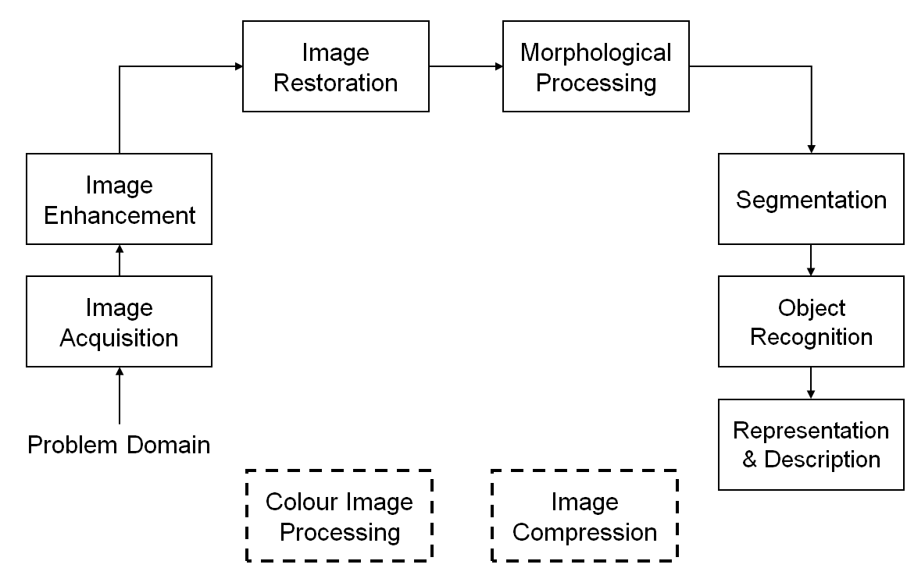

Human Visual System: The best vision model we have. Knowledge of how images form in the eye can help us with processing digital images. Scientists try to copy working of the human visual system to develop computerized system to capture images.

**Image Representation:** Digital image is composed of M rows and N columns

of pixels each storing a value. Pixel values are most often grey levels in the range 0-255(black-white).

Sampling: A digital sensor can only measure a limited number of samples at a discrete set of energy levels

Quantization is process of converting a continuous analogue signal into a digital representation of this signal.